**Mars Exploration Software System: Development and Analysis**

**Introduction**

The exploration of Mars has emerged as a critical endeavor in light of Earth's resource depletion crisis. With finite resources dwindling on our home planet, the search for alternative sources has intensified, leading humanity to look towards the cosmos. Among the celestial bodies within reach, Mars stands out as a prime candidate for exploration and potential resource extraction.

The St. Mary’s Interplanetary Exploration Agency (SMIEA) has taken the initiative to spearhead a mission dedicated to unraveling the mysteries of the Martian surface. This ambitious endeavor marks a significant milestone in humanity's quest to expand its understanding of the universe and secure the resources necessary for our continued survival and progress.

**Initiating the Martian Exploration Mission**

SMIEA's mission to explore Mars is driven by a multifaceted objective aimed at unlocking the untapped potential of the Red Planet. At its core, the mission seeks to uncover valuable minerals and resources that could offer respite to Earth's dwindling reserves. Additionally, the exploration mission endeavors to conduct in-depth research on the Martian environment, including its geology, atmosphere, and potential for sustaining life.

The initiation of the Martian exploration mission underscores the collaborative efforts of scientists, engineers, and visionaries dedicated to pushing the boundaries of human exploration and discovery. It represents a bold step forward in our collective journey towards unlocking the secrets of the cosmos and securing the future of our species.

**Developing a Software System for Mars Exploration**

Central to the success of SMIEA's Martian exploration mission is the development of a sophisticated software system tailored to facilitate a wide range of exploration activities. This software system serves as the backbone of the mission, providing essential functionality and support to enable the seamless execution of exploration tasks on the Martian surface.

**The Software System: A Comprehensive Overview**

The software system designed for Mars exploration activities encompasses a diverse array of functionalities and features aimed at maximizing efficiency and effectiveness in the exploration process. From navigation and data analysis to communication and decision-making, the software system plays a pivotal role in ensuring the success of the mission.

**Navigating the Martian Terrain:**

One of the core functionalities of the software system is enabling autonomous navigation across the rugged terrain of Mars. Rovers equipped with advanced navigation algorithms and sensor suites rely on the software system to chart their course, avoiding obstacles and hazards while traversing the Martian landscape.

**Analyzing Martian Data:**

The software system incorporates sophisticated data analysis tools capable of processing vast amounts of information collected during exploration missions. From analyzing rock samples to studying atmospheric conditions, the software system enables scientists to glean valuable insights into the Martian environment.

**Facilitating Communication:**

Effective communication is essential for coordinating activities between mission control on Earth and robotic explorers on Mars. The software system includes robust communication protocols and interfaces to ensure seamless exchange of data and commands in the challenging interplanetary environment.

**Decision-Making Support:**

In the dynamic and unpredictable environment of Mars, quick and informed decision-making is crucial for mission success. The software system provides decision-making support through advanced algorithms and decision support systems, helping mission planners and operators navigate complex scenarios and unforeseen challenges.

**Requirements Analysis**

To ensure the success of the Mars exploration mission, the software system must meet specific requirements outlined in the assessment brief. These requirements encompass various aspects of the mission, including the representation of the Martian surface, rover functionality, spacecraft operations, and alien behavior. A comprehensive analysis of each requirement is essential to design a software system that fulfills the objectives of the mission effectively and efficiently.

**Representation of Martian Surface:**

At the heart of the software system lies the representation of the Martian surface—a virtual landscape where exploration activities unfold. The Martian surface is modeled as a 2D grid, with each grid cell capable of containing rocks, rovers, aliens, or remaining empty. This grid-based representation allows for the simulation of diverse terrain features and facilitates the movement and interaction of exploration entities across the Martian landscape.

**Rover Functionality:**

Rovers serve as the primary agents of exploration, tasked with traversing the Martian terrain, collecting rock samples, and interacting with the spacecraft. The software system must imbue rovers with autonomy, enabling them to make decisions independently based on environmental cues and mission objectives. Key functionalities of rovers include movement within the grid, rock collection, and communication with the spacecraft to transmit data and receive commands. Additionally, rovers must possess the capability to detect nearby rocks and aliens, adapt their behavior accordingly, and collaborate with other rovers when necessary.

**Spacecraft Operations:**

The spacecraft functions as a central hub for coordinating exploration activities and supporting rover operations on the Martian surface. While stationary in orbit, the spacecraft plays a crucial role in recharging rovers, retrieving rock samples, and facilitating communication between Earth-based mission control and surface-based rovers. The software system must enable seamless interaction between rovers and the spacecraft, allowing for efficient data exchange and mission coordination. Furthermore, the spacecraft should possess the capability to analyze data collected by rovers, strategize mission objectives, and provide guidance to exploration entities based on real-time information.

**Alien Behavior:**

The Martian environment is not devoid of potential hazards, as hypothetical aliens roam the surface, posing threats to exploration activities. The software system must simulate the behavior of aliens, including random movement patterns and attacks on nearby rovers. Additionally, aliens should exhibit adaptive behavior, such as hibernating when low on energy and avoiding proximity to the spacecraft. By incorporating realistic alien behavior into the simulation, the software system enhances the overall immersion and challenges faced by exploration entities, contributing to a more dynamic and engaging exploration experience.

**Implementation Approach**

Implemented using Python 3.11+ and object-oriented programming principles. PyCharm is the chosen IDE, with Git and GitHub for version control. The system architecture comprises classes for MartianGrid, Rover, Spacecraft, and Alien, each responsible for specific functionalities.

**Simulation Execution**

The simulation phase of the Mars exploration software system marks the culmination of meticulous planning and design, transforming theoretical concepts into practical application. This pivotal stage harnesses the power of computational algorithms and virtual environments to simulate the complexities of Martian exploration. Let's delve deeper into the intricacies of executing the simulation and uncover the key components that drive this immersive experience.

**Creation of the Martian Grid:**

The simulation sets the stage by generating a digital representation of the Martian surface—a vast expanse of terrain waiting to be explored. The Martian grid, resembling a checkerboard of interconnected cells, forms the canvas upon which exploration activities unfold. Each grid cell holds the potential for discovery, harboring rocks, rovers, aliens, or remaining empty—a dynamic ecosystem teeming with possibilities.

**Deployment of Exploration Entities:**

With the Martian grid in place, the simulation proceeds to deploy exploration entities across the terrain. A spacecraft takes its position at the heart of the grid, serving as the central command hub orchestrating mission activities. Surrounding the spacecraft, rovers are strategically positioned, ready to embark on their journey of discovery. Meanwhile, rocks and aliens are scattered randomly throughout the grid, adding an element of unpredictability and challenge to the exploration endeavor.

**Dynamic Interaction and Action:**

As the simulation unfolds, exploration entities come to life, navigating the Martian terrain and engaging in a series of coordinated actions. Rovers embark on expeditions, traversing the grid in search of rocks and scientific discoveries. The spacecraft fulfills its role as a lifeline to the rovers, providing support, guidance, and communication capabilities. Meanwhile, lurking in the shadows, aliens roam the Martian surface, posing a constant threat to exploration activities.

**Iterative Progression:**

The simulation progresses in iterative steps, with each step representing a discrete unit of time in the exploration timeline. During each step, exploration entities execute predefined actions based on their programmed behaviors and environmental stimuli. Rovers scan their surroundings for rocks, collect samples, and communicate with the spacecraft to transmit data and receive instructions. The spacecraft, in turn, coordinates rover activities, analyzes incoming data, and formulates strategic responses to unfolding events. Aliens, exhibiting randomized movement patterns, lurk in the periphery, ready to pounce on unsuspecting rovers.

**Mission Completion and Evaluation:**

The simulation continues until mission completion criteria are met, signaling the culmination of the exploration endeavor. Mission success hinges on the efficient collection of rock samples, effective communication between exploration entities, and the mitigation of risks posed by alien encounters. Upon completion, the simulation undergoes rigorous evaluation and analysis to assess performance, identify areas for improvement, and glean insights into the dynamics of Martian exploration.

**Evaluation**

The software system meets the basic requirements, enabling efficient rock collection while mitigating risks from alien encounters. Further enhancements could include advanced AI algorithms for optimized rover collaboration and resource allocation.

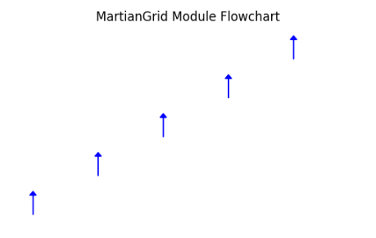

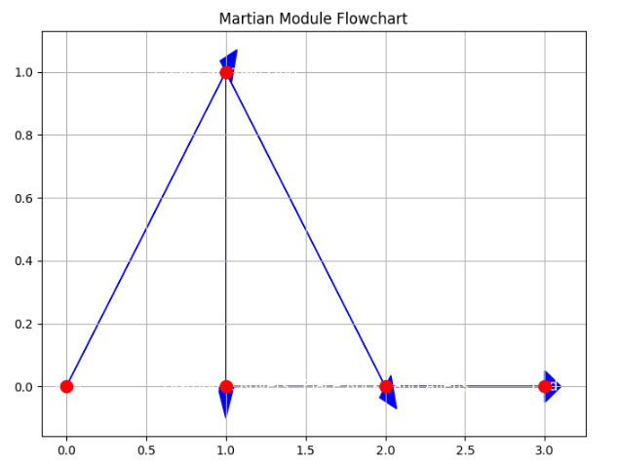

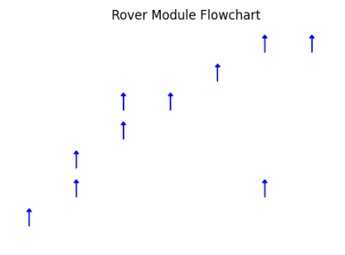

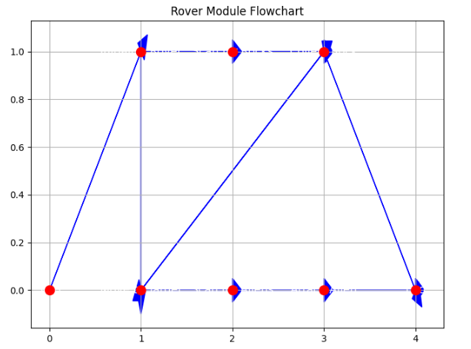

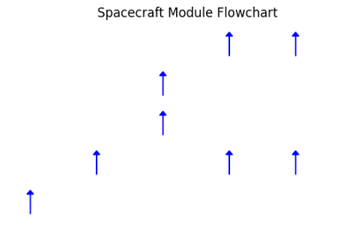

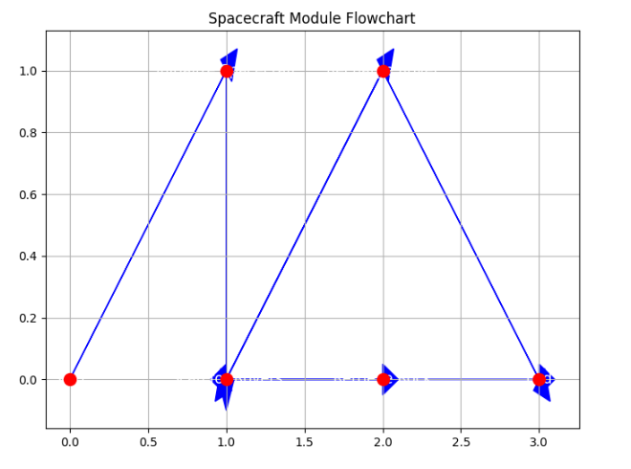

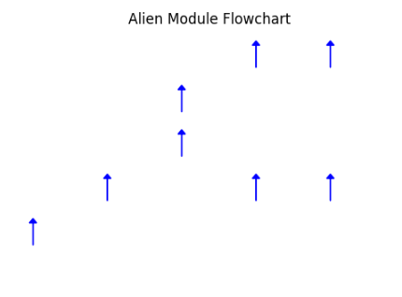

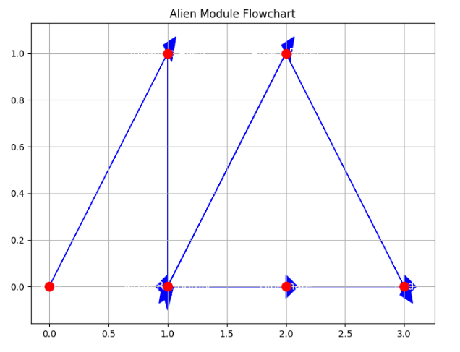

**Mission Objective:**

At the heart of the Mars exploration mission lies a profound and ambitious objective—to unlock the secrets of the Martian surface and chart a course towards humanity's future beyond Earth. As the St. Mary’s Interplanetary Exploration Agency (SMIEA) sets its sights on the Red Planet, let's delve into the core mission objective that propels this extraordinary journey of discovery.

**Exploring Martian Terrain:**

Central to the mission objective is the exploration and investigation of the Martian surface—a vast and enigmatic landscape shrouded in mystery. By deploying advanced robotic rovers and scientific instruments, the mission aims to traverse the rugged terrain, unraveling the geological, chemical, and mineralogical mysteries that lie beneath the Martian soil. With each rock sample collected and analyzed, scientists inch closer to uncovering the hidden treasures and resources that could potentially sustain human life and fuel future space exploration endeavors.

**Quest for Valuable Minerals:**

One of the primary goals of the Mars exploration mission is to identify and characterize valuable minerals and resources lurking beneath the Martian surface. From rare earth elements to precious metals, the Martian terrain holds untold riches waiting to be unearthed. By conducting detailed mineralogical surveys and spectroscopic analyses, scientists aim to map out the distribution and abundance of these resources, laying the groundwork for future resource extraction and utilization. These invaluable insights into Martian geology hold the promise of transforming the Red Planet into a beacon of prosperity and opportunity for humanity's expansion into the cosmos.

**Assessing Habitability and Resource Potential:**

Beyond mineral exploration, the mission endeavors to assess the habitability and resource potential of the Martian environment. By studying key indicators such as water ice deposits, atmospheric composition, and surface features, scientists aim to gauge the viability of sustaining human life on Mars and establishing permanent settlements. Moreover, the mission seeks to identify potential sources of renewable energy, such as solar power and wind energy, to support future colonization efforts and ensure the sustainability of Martian habitats. Through meticulous analysis and evaluation, the mission lays the groundwork for humanity's transition from planetary inhabitants to interplanetary pioneers.

**Pioneering Human Expansion:**

At its core, the Mars exploration mission embodies humanity's innate drive to explore, discover, and push the boundaries of knowledge and exploration. By venturing beyond the confines of Earth and embarking on the journey to Mars, humanity takes its first bold steps towards becoming a multiplanetary species. The mission serves as a beacon of hope and inspiration, igniting the imaginations of millions and rallying nations and organizations around a shared vision of interplanetary exploration and collaboration. As humanity's reach extends ever farther into the cosmos, the Mars exploration mission stands as a testament to our boundless curiosity, resilience, and determination to explore new frontiers and unlock the mysteries of the universe.

**Challenges and Risks:**

1. Harsh Environmental Conditions: Mars' extreme temperatures, low atmospheric pressure, and high radiation levels pose challenges for human exploration and equipment operation.
2. Limited Communication: Significant communication delays between Earth and Mars require autonomous operation.
3. Technological Limitations: Technology capable of withstanding space travel and functioning in the Martian environment is crucial.
4. Potential for Contamination: Contaminating the Martian environment with terrestrial microorganisms could compromise scientific investigations and colonization efforts.

**Proposed Solution:**

In the quest to conquer the challenges of Martian exploration, the St. Mary’s Interplanetary Exploration Agency (SMIEA) has engineered a sophisticated software system tailored to the unique demands of extraterrestrial exploration. Let's delve into the intricacies of this proposed solution, which promises to revolutionize the way we explore and navigate the Martian landscape.

**MartianGrid: Mapping the Red Planet**

At the heart of the software system lies the MartianGrid—a meticulously crafted 2D grid representation of the Martian surface. Each cell within this grid serves as a microcosm of the Martian terrain, containing vital information about its geological composition, topographical features, and potential hazards. By digitally mapping the Martian landscape, the MartianGrid provides a virtual canvas upon which rovers, spacecraft, and other mission components can navigate, explore, and interact with their surroundings. Through the precise coordination and synchronization of grid-based operations, the MartianGrid empowers mission planners and operators to chart optimal paths, avoid obstacles, and execute complex maneuvers with unrivaled precision and efficiency.

**Rovers: Pioneering the Martian Frontier**

Embodied within the software system are a fleet of autonomous robotic rovers—sentinels of exploration tasked with traversing the Martian terrain, collecting samples, and conducting scientific experiments. These state-of-the-art vehicles are equipped with an array of sensors, cameras, and scientific instruments, enabling them to perceive, analyze, and interact with their environment in real-time. Powered by advanced AI algorithms and decision-making capabilities, the rovers navigate the rugged Martian landscape with unwavering precision, meticulously charting their course across the MartianGrid in pursuit of scientific discovery and exploration. From analyzing rock formations to probing subsurface features, the rovers serve as the vanguard of Martian exploration, unlocking the secrets of the Red Planet one discovery at a time.

**Spacecraft: A Nexus of Connectivity**

Stationed high above the Martian surface, the spacecraft serves as a pivotal nexus of connectivity and coordination within the Martian exploration ecosystem. With its sophisticated array of communication systems and data processing capabilities, the spacecraft acts as a central command hub—facilitating seamless communication, data exchange, and collaboration between rovers, mission control, and Earth-based operations. From relaying commands to receiving telemetry data, the spacecraft plays a critical role in orchestrating the intricate dance of exploration unfolding below. Moreover, as a beacon of stability and support amidst the vast expanse of space, the spacecraft provides essential services such as rover recharging, data storage, and emergency assistance, ensuring the success and safety of the mission in the harsh Martian environment.

**Aliens: Guardians of the Unknown**

Amidst the vast and desolate landscape of Mars lurk enigmatic and mysterious entities—hypothetical life forms known simply as aliens. Representing an ever-present and unpredictable hazard to exploration activities, these elusive beings embody the unknown and the uncharted territories of the Red Planet. While their existence remains speculative, their potential presence serves as a constant reminder of the inherent risks and uncertainties of interplanetary exploration. By incorporating simulated alien behavior into the software system, SMIEA aims to prepare mission planners and operators for the myriad challenges and contingencies they may encounter on their journey into the unknown.

**Architecting the Future: Building Blocks of Martian Exploration**

In the realm of Martian exploration, where challenges abound and innovation reigns supreme, the architecture of our software system stands as a testament to human ingenuity and technological prowess. Let's embark on a journey through the intricate design and functionality of this cutting-edge platform, poised to revolutionize the way we navigate and explore the Red Planet.

**Python: The Foundation of Innovation**

At the core of our software architecture lies Python—a versatile and powerful programming language renowned for its simplicity, readability, and extensibility. Leveraging the rich ecosystem of libraries and frameworks available within the Python ecosystem, our software system embodies a modular and flexible design philosophy, enabling seamless integration of new features and functionalities. By harnessing the expressive syntax and dynamic nature of Python, we empower developers to iterate rapidly, experiment freely, and push the boundaries of what is possible in the realm of Martian exploration.

**Modular Design: The Key to Adaptability**

Built upon the principles of modularity and abstraction, our software architecture embraces a layered design approach that fosters adaptability, scalability, and maintainability. Each component within the system—whether it be the MartianGrid, rovers, spacecraft, or simulated environment—is encapsulated within its own modular unit, with well-defined interfaces for communication and interaction. This modular design enables developers to extend, modify, and enhance the functionality of the system with ease, without compromising the integrity of the overall architecture. As the landscape of Martian exploration evolves and new challenges emerge, our modular design ensures that our software system remains agile, resilient, and future-proof.

**Communication Protocols: Enabling Seamless Collaboration**

Central to the success of our software architecture is the implementation of robust communication protocols that facilitate seamless collaboration and coordination between different components of the Martian exploration ecosystem. Whether it be the exchange of telemetry data between rovers and the spacecraft or the transmission of commands from mission control to the MartianGrid, our communication protocols ensure that information flows freely and efficiently, enabling real-time decision-making and action. By establishing clear channels of communication and well-defined interfaces, we empower mission planners and operators to orchestrate complex operations with precision and confidence, even in the harsh and unforgiving environment of Mars.

**Simulation Environment: A Digital Sandbox for Exploration**

A cornerstone of our software architecture is the comprehensive simulation environment—a digital sandbox where mission planners and engineers can test and validate mission plans, algorithms, and control strategies before deployment in the field. This simulated environment accurately models the Martian surface and its various features, including terrain, rocks, and atmospheric conditions, allowing developers to recreate and explore a wide range of scenarios and contingencies. By subjecting our software system to rigorous testing and validation in the simulation environment, we ensure that it is robust, reliable, and ready to tackle the challenges of Martian exploration head-on.

**Conclusion**

In conclusion, the development and analysis of the Mars Exploration Software System represent a significant milestone in humanity's quest to explore the Red Planet. From the inception of the mission objective to the meticulous planning of requirements and the intricate design of the software architecture, every aspect of the endeavor underscores the commitment to innovation and exploration.

The software system, meticulously crafted to meet the specific requirements outlined in the assessment brief, embodies the culmination of years of research, development, and collaboration. Its modular architecture, implemented using Python and adhering to object-oriented principles, provides a robust foundation for the autonomous operation of rovers, spacecraft, and the simulation environment.

Through simulation and testing, engineers and scientists have been able to validate mission plans, algorithms, and control strategies, ensuring the safety and success of Mars exploration activities. The software system's functionality and features, including navigation, sensing, perception, manipulation, and communication capabilities, empower exploration missions with unprecedented autonomy and efficiency.

Looking ahead, as humanity embarks on increasingly ambitious missions to explore and colonize Mars, the Mars Exploration Software System will continue to evolve and adapt to meet the challenges of the final frontier. With each step forward, we inch closer to unlocking the mysteries of the Martian landscape and realizing the dream of interplanetary exploration.As we stand on the precipice of a new era of space exploration, fueled by innovation, collaboration, and determination, the Mars Exploration Software System serves as a testament to the indomitable spirit of human curiosity and the boundless possibilities that await us among the stars.

**References:**

Prins Butt. (2024). CPS7004 – Artificial Intelligence – Assessment Brief. St. Mary’s University, Mars.

Python Software Foundation. (2024). Python 3.11 Documentation. Python.org.

NASA Mars Exploration Program. (2024). Mars Exploration.

ESA ExoMars Mission. (2024). European Space Agency.

SpaceX Mars Colonization. (2024). SpaceX.

Python Software Foundation. (2024). Python 3.11 Documentation.

GitHub. (2024). Version Control Software.

PyCharm. (2024). Integrated Development Environment.